**Project Idea/ System Request:**

Automating Business Processes for Manual Wholesale and Retail Clothing Stores in Polwell Super Market, using a DBMS

**Introduction:**

Polwell Super Market is an import based clothing shopping mall where most of the clothing stores started their businesses in the 1990’s. However, Most of the business processes in these stores are very manual, with unstructured documentations, and poor inventory tabs. Our project idea is to analyse in detail the business processes in these stores, and find scope for automation and digitisation using a DBMS.

**Business Need:**

It is not uncommon for the store managers of these stores to make a lot of business decisions based on guesswork and memory as opposed to being based on data analytics. Even the salesmen need to memorise product information to form a sales pitch. It is not uncommon to have frequent theft cases, due to poor inventory tracking and employee mismanagement. Human errors creep in when reading or writing these documents, as these documents mostly have ambiguous handwritten formats.

**Our Activity (Scope of this project):**

We seek to carefully understand the details of the business processes that take place in a typical Clothing store in Polwell Supermarket, through Requirement Engineering Techniques.  
The goal is to identify scopes for automation and digitisation by identifying data flow within the activities, and construct data models of the major data elicited. And finally create a Database for the store.

**Business Requirement Specification:**  
***Requirements Elicitation:***

We investigated Various Shops in Polwell Supermarket, namely Azad Enterprise and Antu Moni Enterprise. We carefully analysed their business processes through observation, and managed to interview the managers of these shops do gain deeper insight about their As Is System. They were very cooperative with us in identifying lackings and room for improvement and automation and digitisation of their manual processes. J.A.D sessions were conducted to determine the functionalities of the To Be System.

Requirements Were Gathered Mainly by:

1. Observation
2. J.A.D Sessions and Interviews
3. Document Analysis

**Documents Gathered:**

**Product Information:**

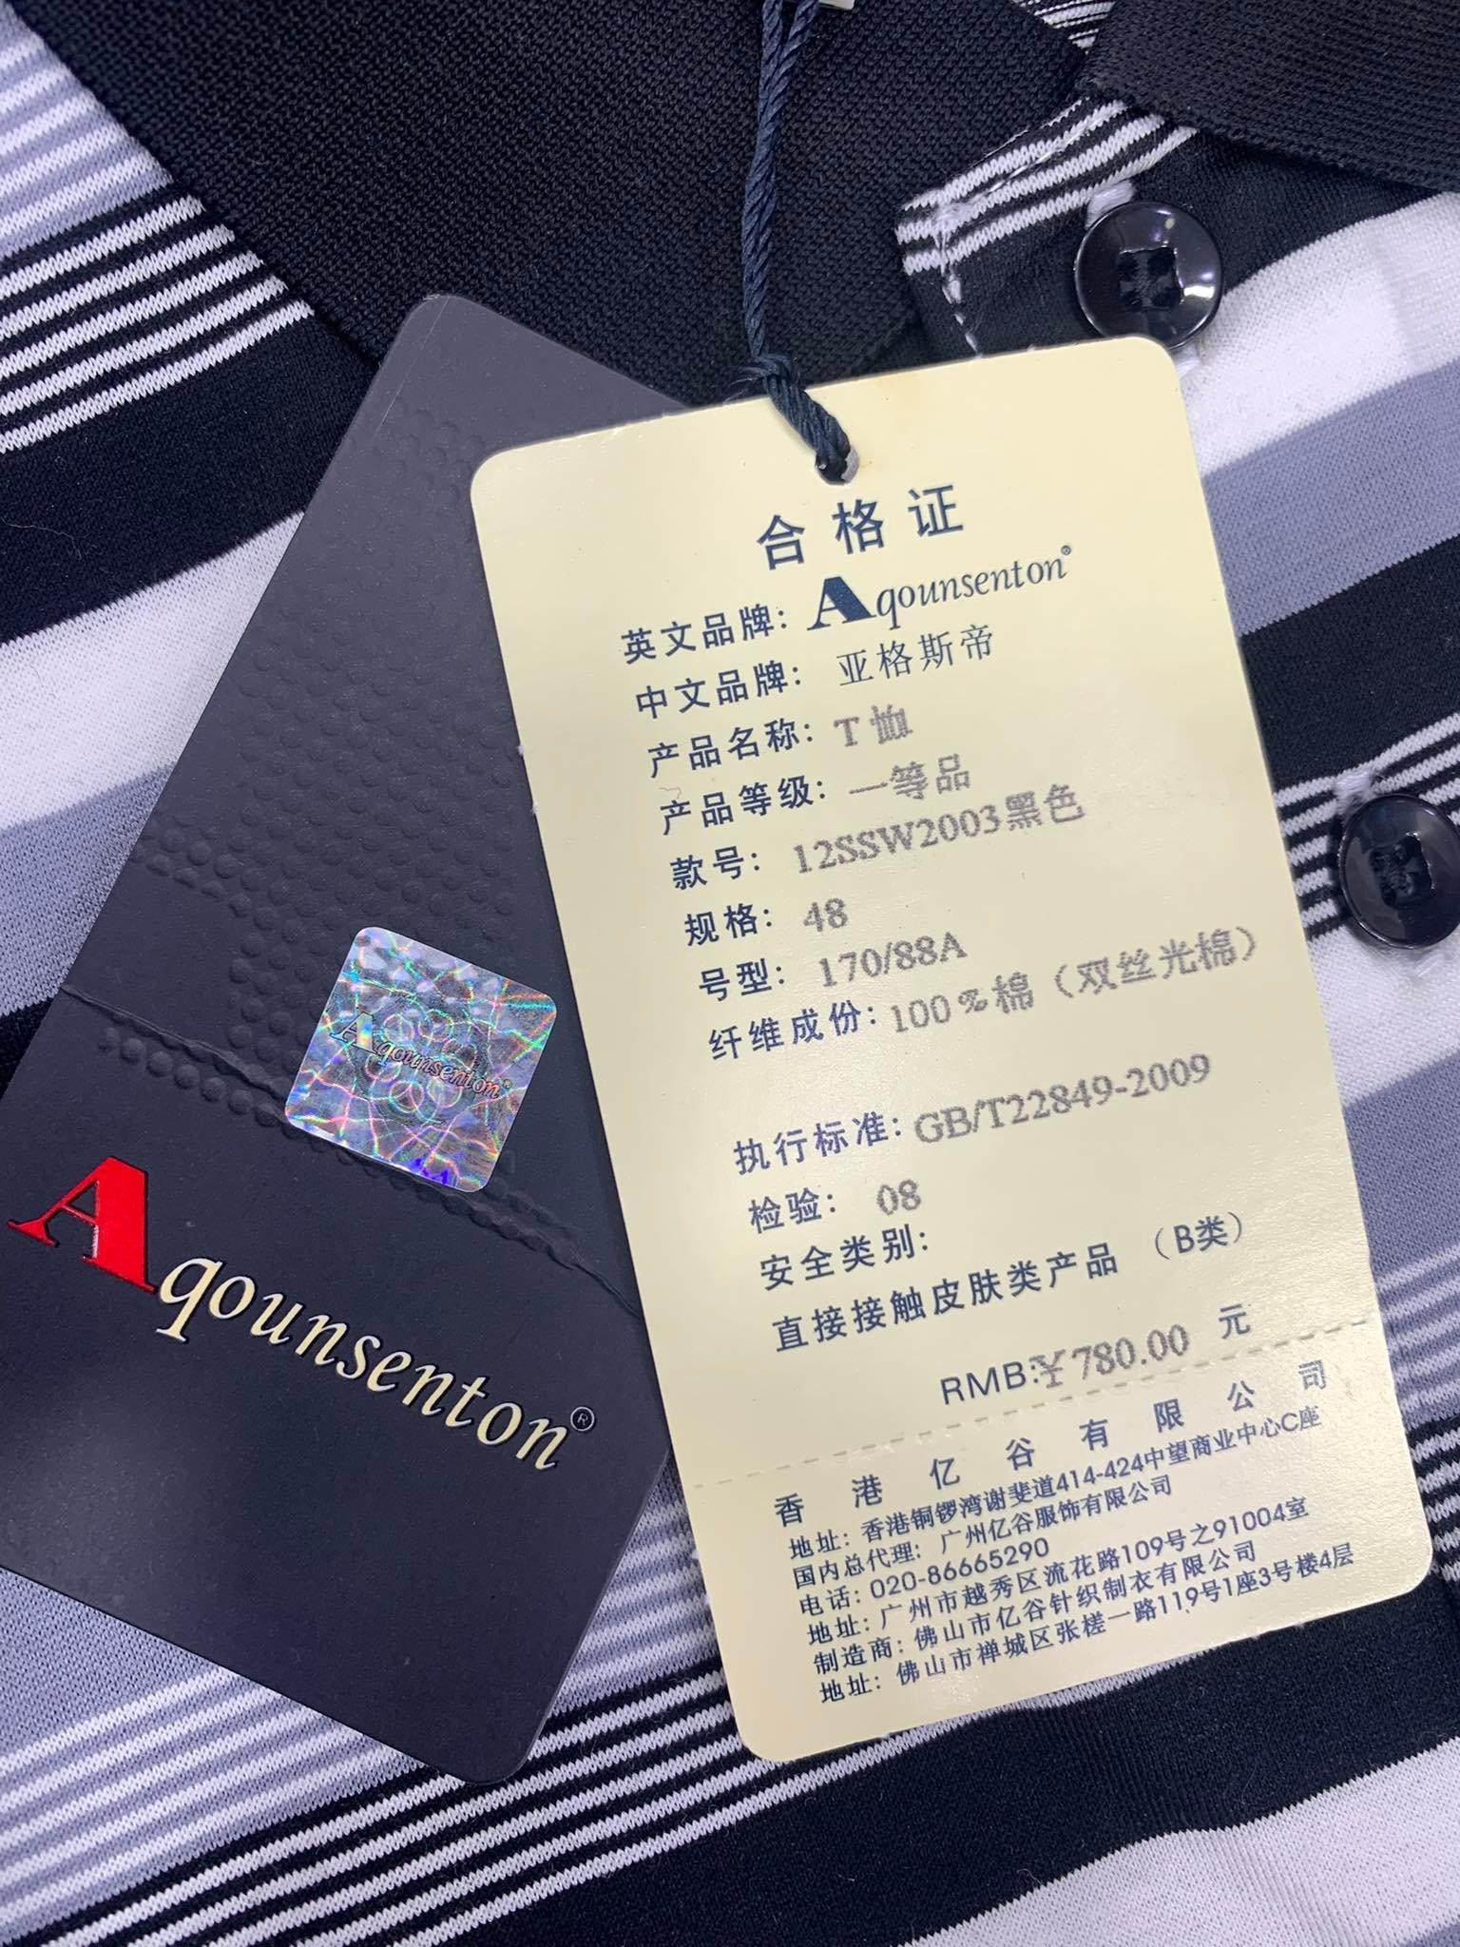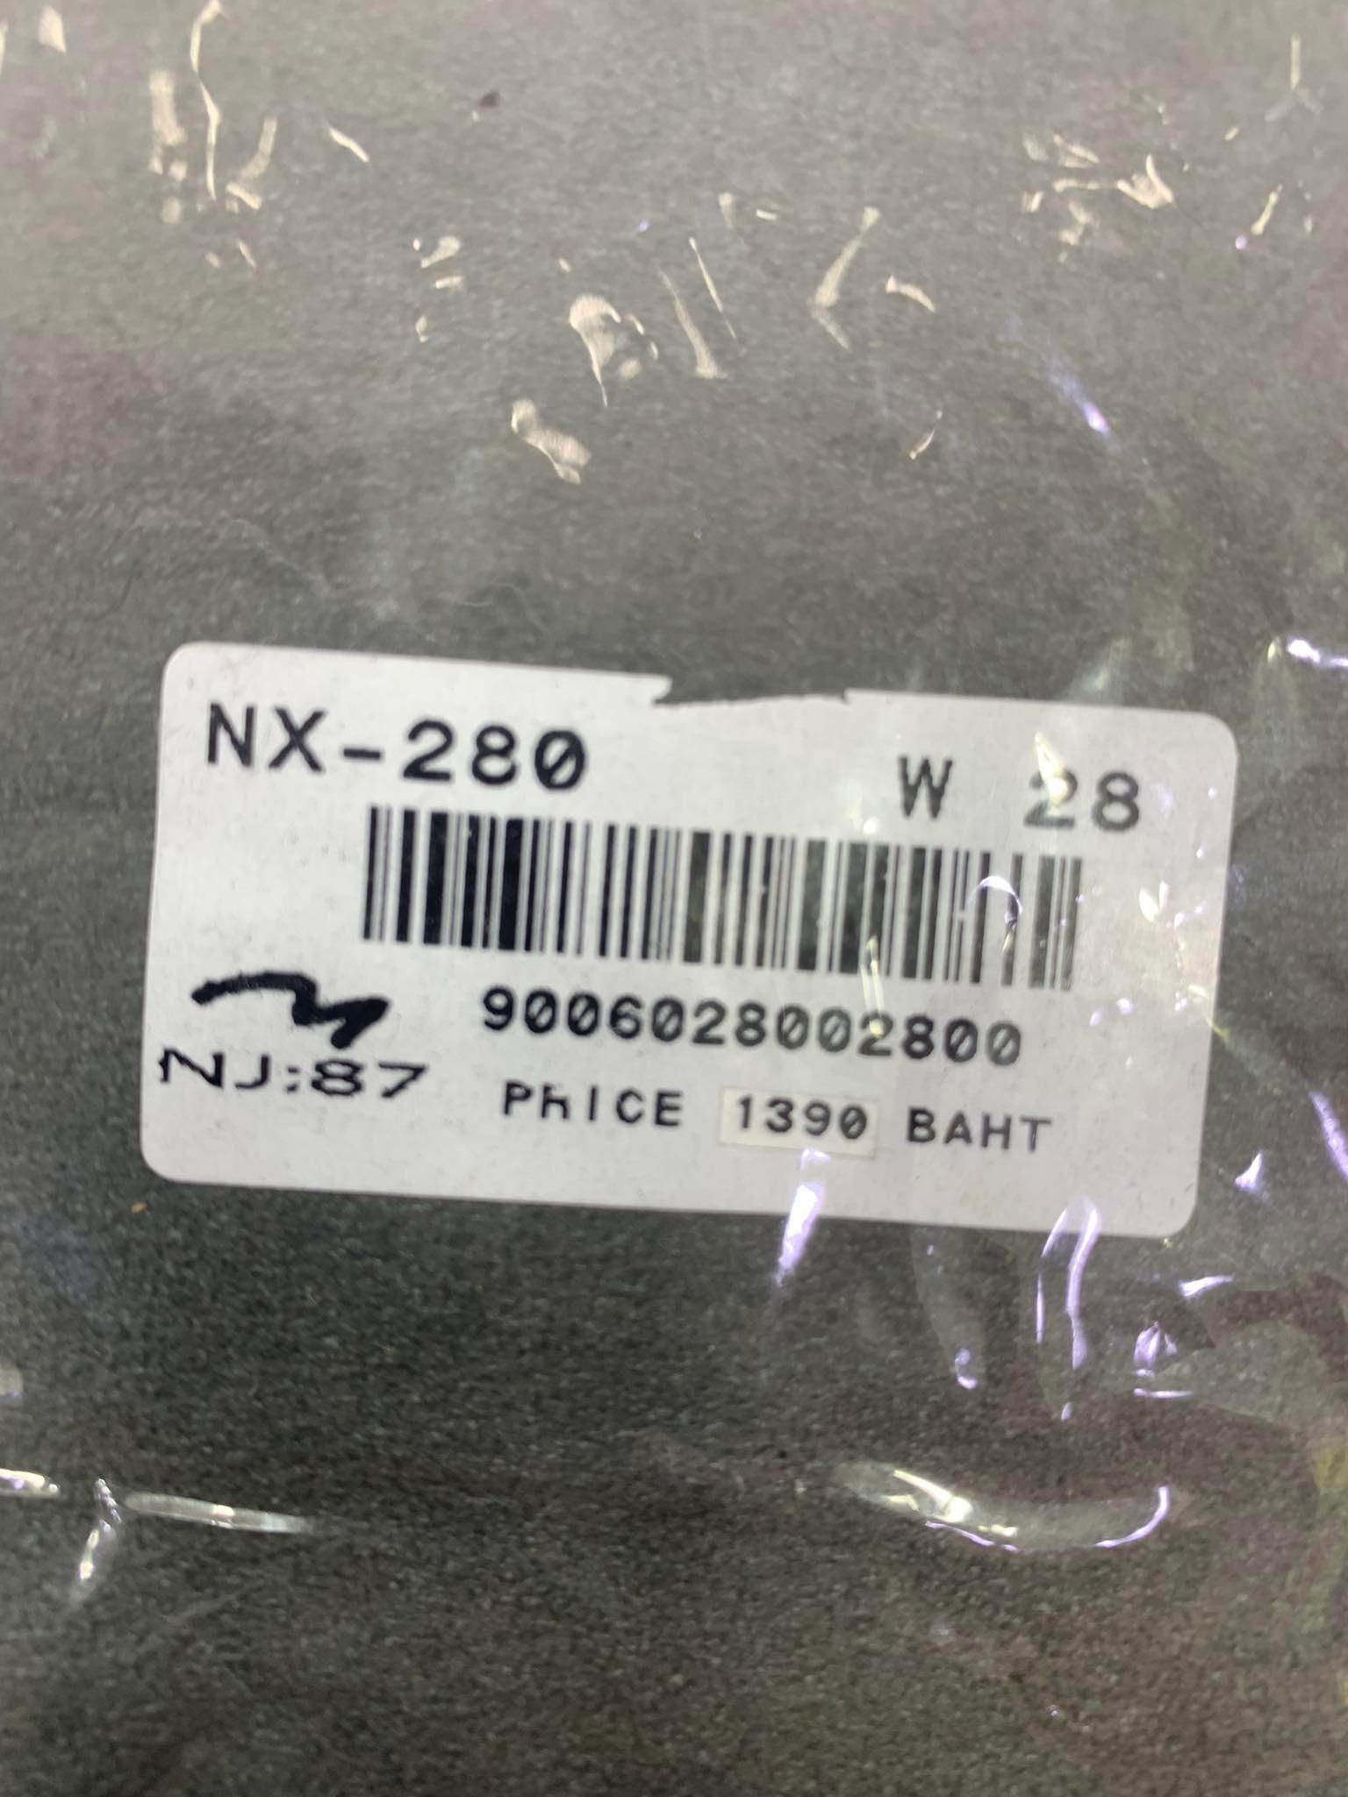

**Document 1: Card Tags, And Stickers**

Description: Found attached to products. They hold various information like: buying price, size & Material Information, and also tutorials on how to wash

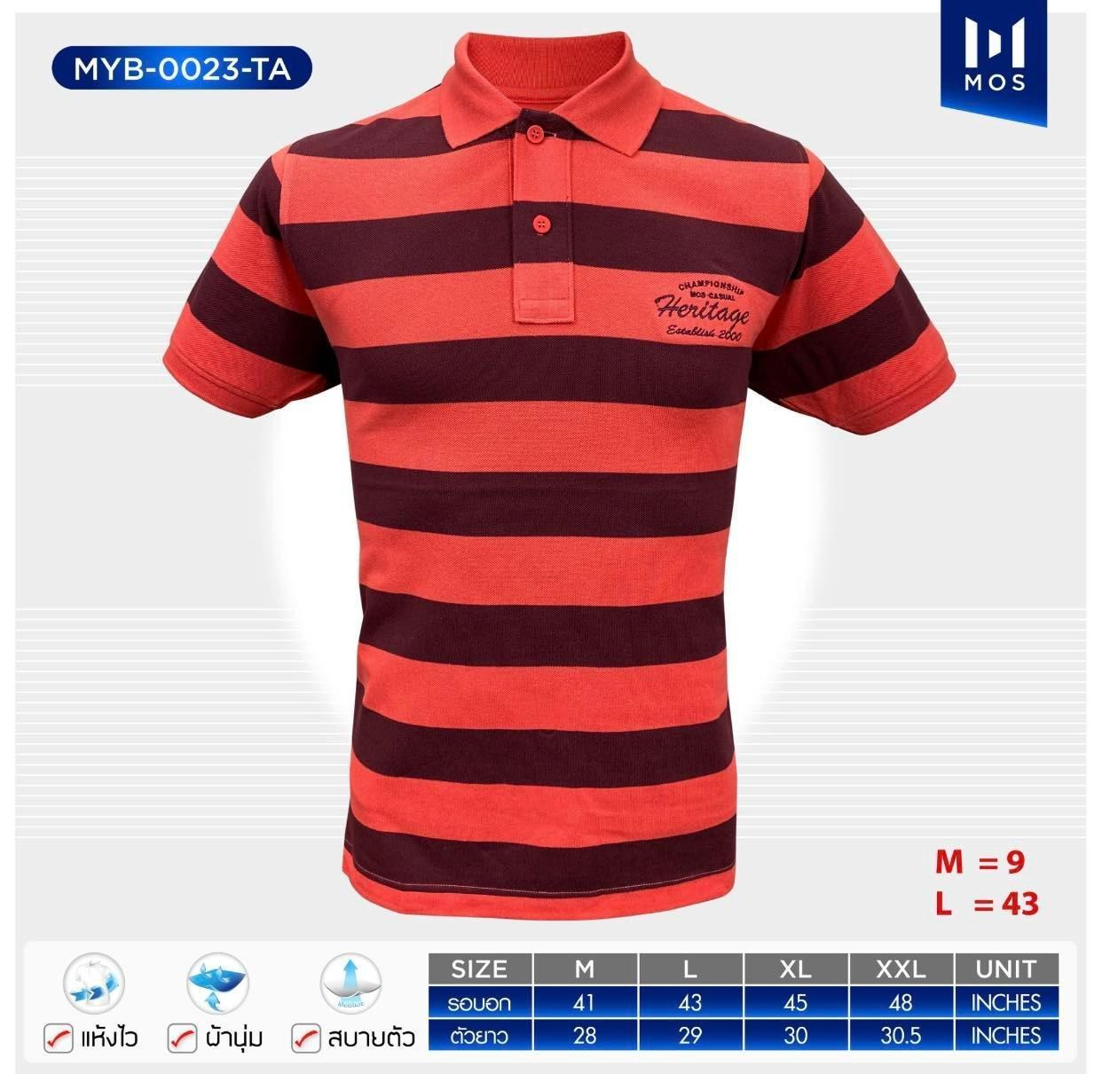

**Document 2: Graphical Model of the Product:**

Description: The Document contains(from top-down):

1. The Brand and the DesignNumber/Product Id
2. A Graphical model of the product
3. Fabric Information
4. Available Sizes and their Measures in Inches

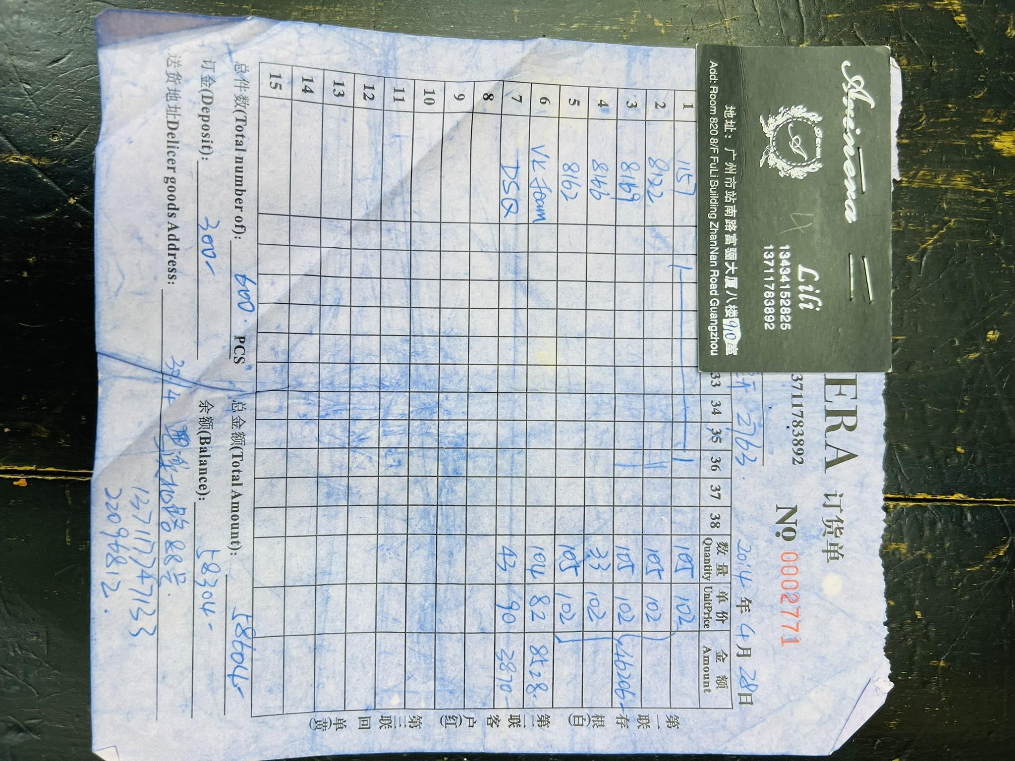

**Document 3: Memo from supplier**

**Description:** This Memo shows the product model and the quantity supplied from that particular product. It also shows the unit amount of every product design.

Then, at the very end , we have a total amount of product and expenses. Then , finally we found the address of the shop.  
Product model: At first we have the product model number. Then we have a size chart. Size charts have various numbers which will indicate the amount of product we will order.   
Then we have a column that shows the amount of products and another column that shows the unit price of individual products.

Then, we have the total number of products we ordered. And expenses for that. Balance is expenses when we deduct deposits from it.

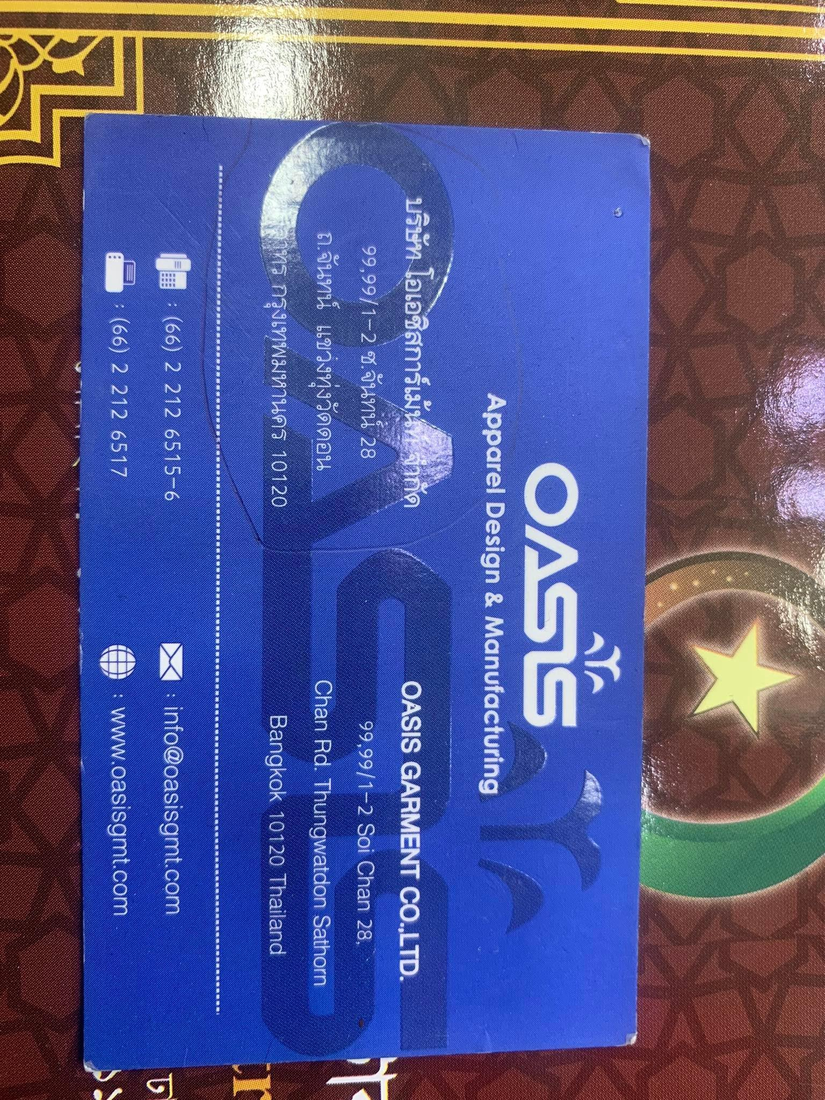

**Document 4: Supplier Business Card**

Description: Used to look up Supplier information. The card contains notable contact information of the supplier such as (Supplier name, Address, Telephone and fax number, Email, and Website).

**Payment and Transaction Information:**

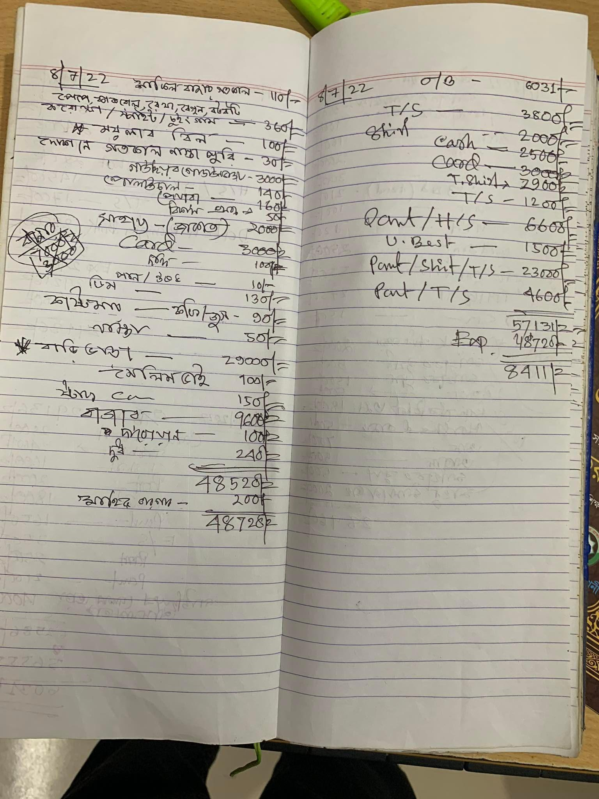

**Document 5: Tally Khata**

Description:

**Tally Khata**:

**Description**: It is the total amount of expenses and sales in a day. The amount of sales and expenses and benefits in a day is being shown here.

**Right Page**: On the right page, we have daily expenses . Amount of daily things like: rent, breakfast bills, stuff bills, security bills and daily chores .

**Sales Records**: the sales records are on the left page. There are T-shirt sales over 3800 tk. There are also Shirt sales here. As this shop accepts both cards and cash. The shirt sold in cash was about 4500 Tk .On a particular day , we were paid through a card worth 3000 Tk . We also sold pants ,shirts and T-shirts worth 6600, 23000 and 4600 respectively.

So, Total purchase was worth 57131 Tk . And as we can see the expense was worth 48720 Tk.   
Total benefit was : 57131 - 48720 = 8411TK

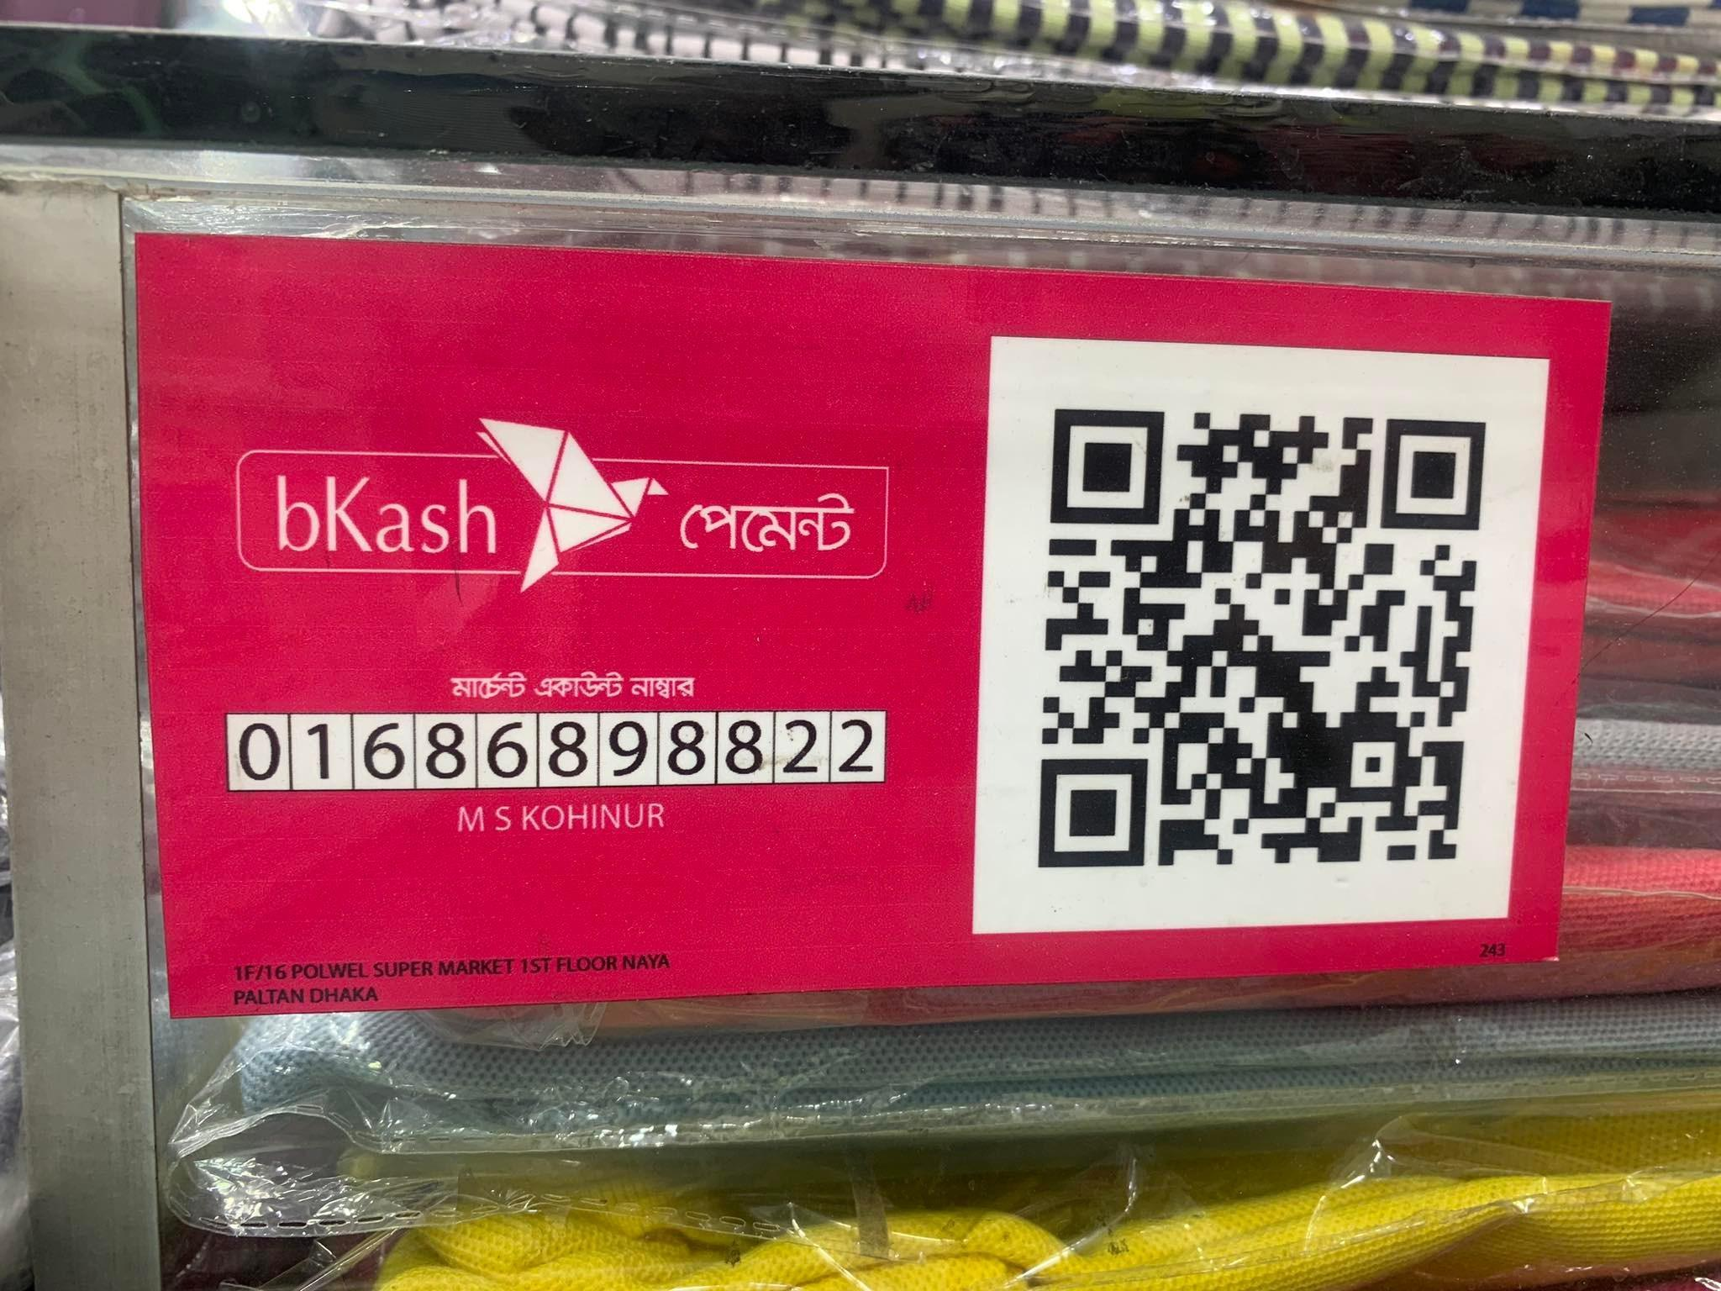

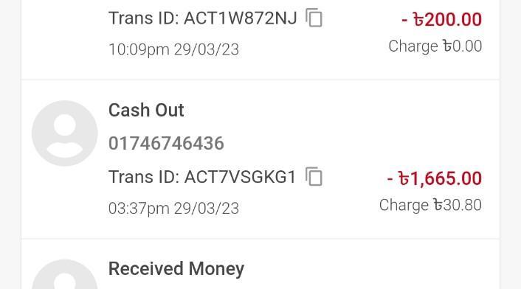

**Document 6**: Payment with Bkash

Description: The upper picture is a bKash Payment Placard Containing the Payment Number of the Shop along with a QR code to Scan. The Bottom picture gives us an example of a bKash Transaction Entry. Notable are the (Sender Number, Transaction ID, Date/TIme of transaction, the Amount).

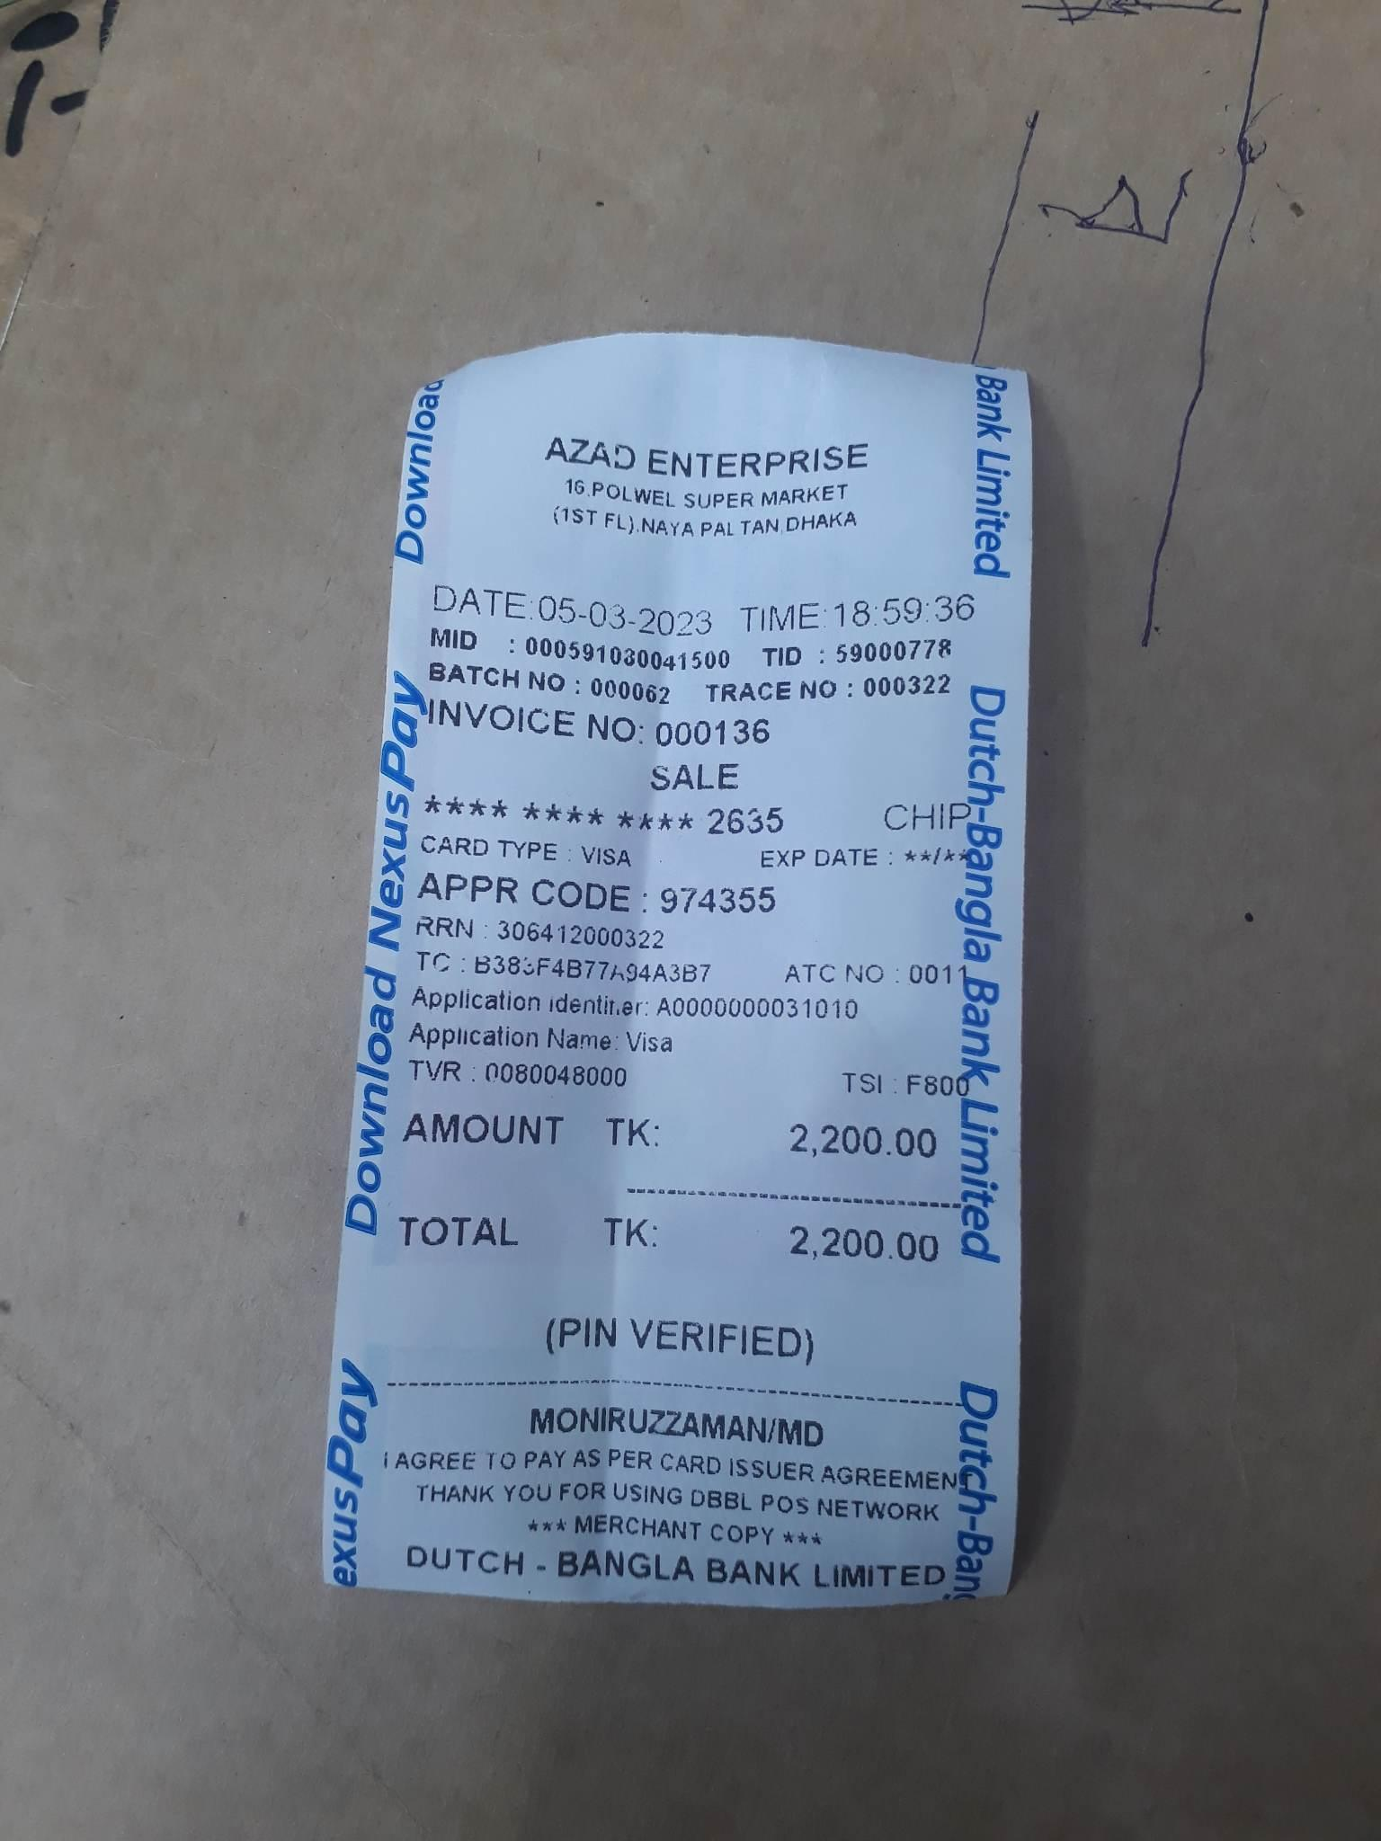

**Document 7: Atm Slip**

Description: In This ATM slip , we can say a lot about the shop and its work nature.

First, there is the name of the shop and address of the shop. Then there is the time and date of purchase. And then ,there is some info that requires the address of the product. In case of finding it . Then ,there is a payment method . We have card , cash. Then , there is the amount of product . and finally there is the bank or the institute that is linked with that company.   
**Product Info**: 974355. Lets see this number. It indicates the unique individual number of a certain product..

**Transaction info**: 30641200022. This transaction number will describe every purchase individually.

**Inventory Tabs Information:**

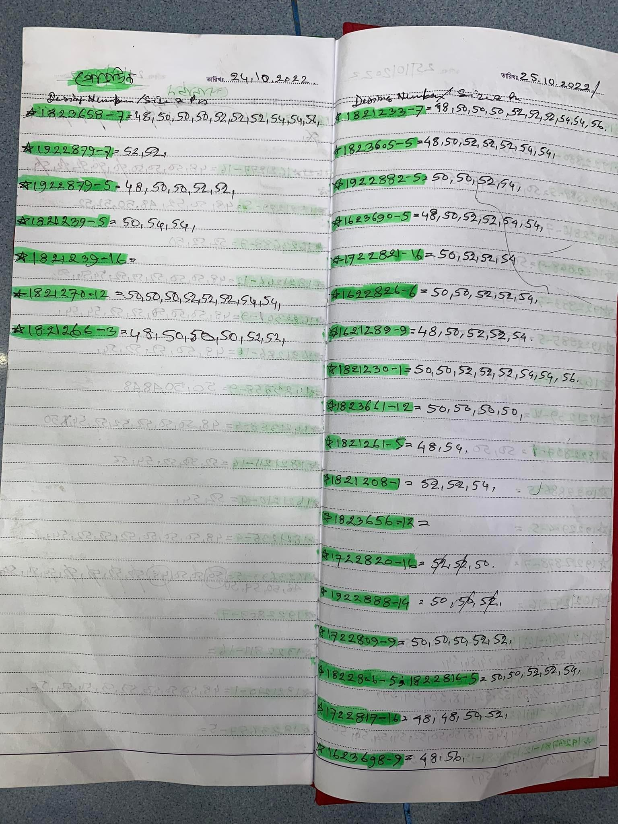

**Document 8: Godown Khata**

In the Go-Down Khata , we have two things. First one is the Design number provided by the dealers and followed by the design number , the size of that product. As we can see , there are sizes of 48 , 50, 52, 54 and so on. As we can see , some numbers are more than once , these are coming more than once there.

As-Is System Analysis:

In as is system Data entry for transaction is done by the following Business Processes:

Process 1-

**Normal Checkout:**

1. The Salesman inform Manager/Cashier about products,payment method & selling price
2. If approved then customers can pay by cash ,ATM,Mobile Banking.In this process staff record sales,product type,amount,selling price.
3. If Payment is done by ATM or Mobile Banking, The Sales Should also be recorded as expense so as to cancel out any on non-cash transaction, for Valid C/B Calculation

In this manual process we face some problems Format ambiguity,Product ambiguity,Redundancy,Spelling error,proof.

Process 2-

**Expense Recording:**

1. When Cash is Expensed from the Cash Register
2. The Manager records this expense in the Tally Khata in the format:

Description – amount expensed

Process 3-

**Record Godown Inventory** :

In as is system Go Down processed by Go Down Document by those steps

1. Box unpack
2. While Box not empty then remove items
   1. For each item removed, append its size to its design Number in the Godown Khata.
   2. (Design-Number: size list) will be the record format of the Godown Khata

Process 4-

**Transfer Products from GoDown to ShopInventory**

1.Remove Items from Go Down to Shop

2.Update Godown Khata & update Shop Khata

Process 5-

**Update Remaining ShopInventory**

1.Identify products sold from memory using the ambiguous Tally records (type description, cost) for the day.

2.Subtract ‘Products sold ‘ from Shop Khata, to form remaining list count

3.Count Remaining items & match against remaining count list to check for theft.

4. If matches, update the Shop Khata with the remaining count list

Process 6-

**Sales Analysis:**

1.Compare Inventory list of beginning of a Quarter & End of a Quarter

2.Determine Amount of each product sold

Problem: Manual counting error,Poor tally analysis

Problems:

Process 7-

**Forming a Sales Pitch:**

1.Inspect The Product to get Products Material,type info

2.Inspect Band name,size from tag

3.Remember Buying Price and import info

4.form sales pitch

Human error(memory),Buying price ,import info

**To-Be System Requirements:**

Use Case 1-

**Sales Analysis:**

**Actor: Manager**

Description: Automate the Calculation of Amount Sold…….

1. Manger Enters Beginning Date, Ending Date, and Chooses the Product
2. The Shop Count, and All Godown Counts of that Product for the Beginning and Ending Dates are retrieved accordingly
3. Amount of that Product Sold within the Time Period is Computed and Displayed to the Manager.

In: (Input - Source)

Beginning Date, Ending Date, Product Choice — Manager

The Shop Count at Beginning Date — ShopInventory DataStore

The Godown(Num) Count at Beginning Date — Godown(Num) DataStore

The Shop Count at Ending Date — ShopInventory DataStore

The Godown(Num) Count at Ending Date — Godown(Num) DataStore

Out: (Output - Destination)

Amount of the Product Sold — Manager

Use Case 2-

**Get Product Info:**

**Actor: Salesman**

Description: Automated Product Info Look Up System…

In: (Input - Source)

Product ID— Salesman

Out: (Output - Destination)

Product Info — Product DataStore

Use Case 3-

**Get Salesman Performance Report**

**Actor: Manager**

Description: Generate Performance Report for Each Salesman

1. Need to Precisely Track Salesman Performance,
2. At the End of the Year:
3. For Each Salesman:

3.1 Retrieve their Sales Records within the current year From the Sales Datastore:

3. 2 Generate a Performance Report for the Salesman, And Send it To the Manager

In: (Input - Source)

Salesman Info - Salesman Datastore

Date — Clock System

Sales - Sales Datastore

Out: (Output - Destination)

Performance Report — Performance Report Datastore

Use Case 4-

**Employ:**

**Actor: Manager**

Description: Add/Employ a Salesman

1. Manager Enters Salesman’s
2. NID
3. Photo
4. Educational Certificate
5. Character Certificate
6. NOC Objection Certificate (For Salesmen who had previous job experience)

Forms a Document Record of the Salesman, and Store it in Salesman Datastore

In: (Input - Source)

1. NID
2. Photo
3. Educational Certificate
4. Character Certificate
5. NOC No Objection Certificate

—— Manager

Out: (Output - Destination)

Salesman Record — Salesman Datastore

Use Case 5:

**Record Godown Inventory**

**Actor: Inventory Clerk**

Description: Unpack Carton, and add the products to a Godown Inventory.

1. Inventory Clerk Enters Go Down Entry Info (e.g. Product, Size, Amount) to Be Added
2. IF Product doesn’t exist in Product Datastore:

Create The appropriate Product Entry for Product Datastore (Done by manager)

1. Inventory Clerk Chooses the Godown No. to be Added to
2. The Number of Products of the DesignNumber and Size is Added to that GoDown DataStore

In: (Input - Source)

Godown Entry Info, Godown No. — Inventory Clerk

Product Info — Manager

Out: (Output - Destination)

Godown Entry- Godown(No.) Datastore

Product Entry— Product Datastore

Use Case 6:

**Transfer Products from GoDown to Shop Inventory**

**Actor: Inventory Clerk**

Description: The Inventory Clerk Removes Product from a Godown to the Shop Inventory

1. Inventory Clerk Enters Product, Size and Amount to Be Transferred.
2. Inventory Clerk Chooses the Godown No. to be Transferred from.
3. The Number of Products of the DesignNumber and Size is removed from GoDown(No.) DataStore, and Added to the ShopInventory Datastore

In: (Input - Source)

Product, Size, Amount, Godown No. — Inventory Clerk

Out: (Output - Destination)

Updated Godown Entry — Godown(No) Datastore

Updated ShopInventory Entry — ShopInventory Datastore

Use Case 7-

**Record Sales:**

**Actor: Manager**

Description: Validate and Record Sales, Update the ShopInventory Datastore accordingly

1. Manager Enters ProductList:
2. For Every Product:

2. 1 IF the Product Exists in the ShopInventory DataStore, Proceed

2. 2 Else Deny Sales

1. Manager enters Payment Method, Selling Price and Salesman who confirmed the sale
2. If Payment Method= Bkash:

Manager Enters Bkash Transaction Info

1. If Payment Method= ATM:

Manager Enters Atm Transaction Info

1. The Clock System is Used to determine the Time of Sale
2. The Sales Entry is Formed and Added to the Sales Datastore
3. The Product amounts are removed from the ShopInventory Datastore

In: (Input - Source)

ProductList, Payment Method, Selling Price, Salesman, Transaction Info —— Manager

Date/Time — Clock System

Out: (Output - Destination)

Sales Entry — Sales Datastore

Updated ShopInventory Entry — ShopInventory Datastore

Use Case 8-

**Record Expense:**

**Actor: Manager**

1. Manager Enters Expense Info:

Category, Amount, Description (Categories Needs to be determined)

Expense Type (e.g Cash, Bkash, ATM)

1. Clock System Adds in Date and Time Info
2. Expense Entry is Formed and added to Expense Datastore

In: (Input - Source)

Expense Info — Manager

Date/Time — Clock System

Out: (Output - Destination)

Expense Entry — Expense Datastore

Use Case 9-

**Calculate C/B**

**Actor: Manager**

Description: Automated Calculation of the closing balance C/B

1. When Closing the Shop:
2. C/B calculated from the previous Working Day is used as O/B
3. The Cash Sales from Sales Datastore for the current day are added up to get Total Sales of the Day
4. The Cash Expenses from Expenses Datastore of the current day are added up to get Total Expenses of the Day
5. C/B is calculated by : Sales + O/B - Expenses
6. C/B is stored as O/B for the next day and displayed to the manager

In: (Input - Source)

O/B — O/B records

Cash Sales — Sales Datastore

Cash Expenses — Expense Datastore

Out: (Output - Destination)

C/B — O/B records, Manager

Use Case 10-

**Supplier info look up:**

**Actor: Manager**

Description: Look up Supplier information

Need Supplier Datastore

**Data Requirements:**

We have identified a few Data Stores that abstracts the Persistent Information held in Various Documents in the As-Is System, or as required from various Usecases of the To-Be System.

**(Data Stores — Documents Abstracted)**

1. **ShopInventory DataStore — Shop Khata**
2. **Godown(No.) DataStore — Godown Khata**
3. **Product Datastore — Internal Clothing Labels, Price Sticker, External White Hard Paper Tags, Memo, Graphical Product Model**
4. **Salesman Datastore (non- Existent)**
5. **Sales Datastore — Right pages of Tally Khata**
6. **Expense Datastore — Left pages of Tally Khata**
7. **Performance Report Datastore (non- Existent)**
8. **Supplier Datastore — Supplier Card**

Data Modelling:

Entity Relationship Modelling was used to model the major persistent data.

The Entity Relationship Diagram:

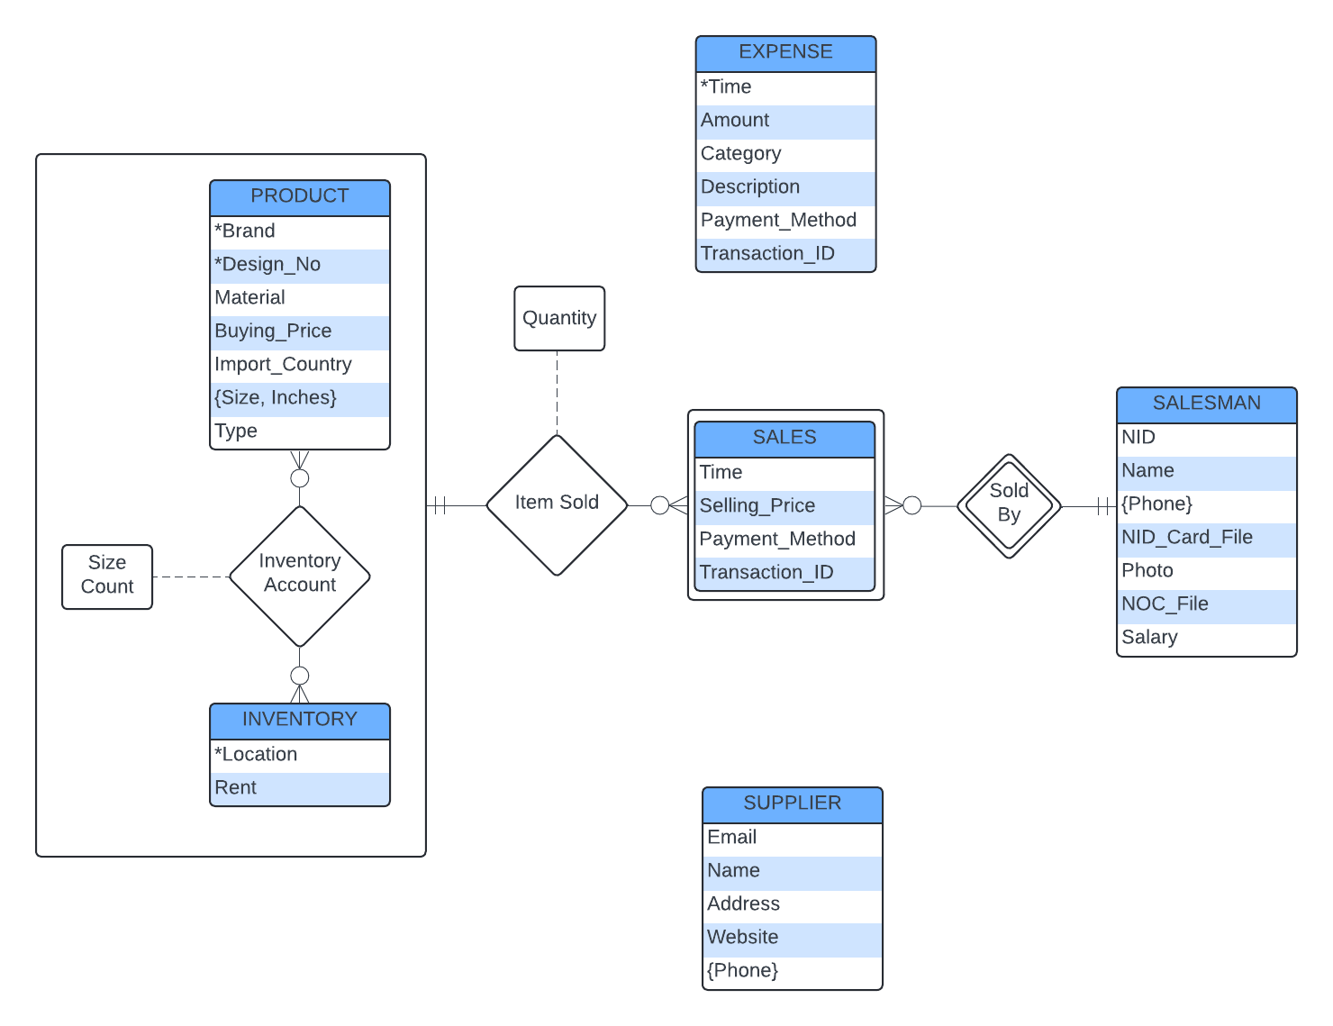

The Entity Relationship Diagram Features:  
  
1. Strong Entity Sets:

* PRODUCT
* INVENTORY
* SALESMAN
* SUPPLIER
* EXPENSE

2. Weak Entity Set:

* SALES which depends on SALESMAN, and is identified by the identifying relationship Sold By.

(Note: Two Sales can be done simultaneously, hence a the Salesman who sold it should be included along with the Time of Sale to form the superkey)

3. Complex Attributes:

* Multi-valued Attribute Phone belonging to SALESMAN and SUPPLIER
* Composite Muliti-valued Attribute: multiple (Size, Inches) pairings belonging to a PRODUCT

4. Relationship Sets:

* INVENTORY ACCOUNT
* ITEM SOLD
* SOLD BY

4. Aggregation:

* Aggregating the Relationship Set INVENTORY ACCOUNT so that it can participate in the Relationship ITEM SOLD.

Data Designing:

A Relational Database was designed using MySQL.

MySQL Database Schema Diagram:  
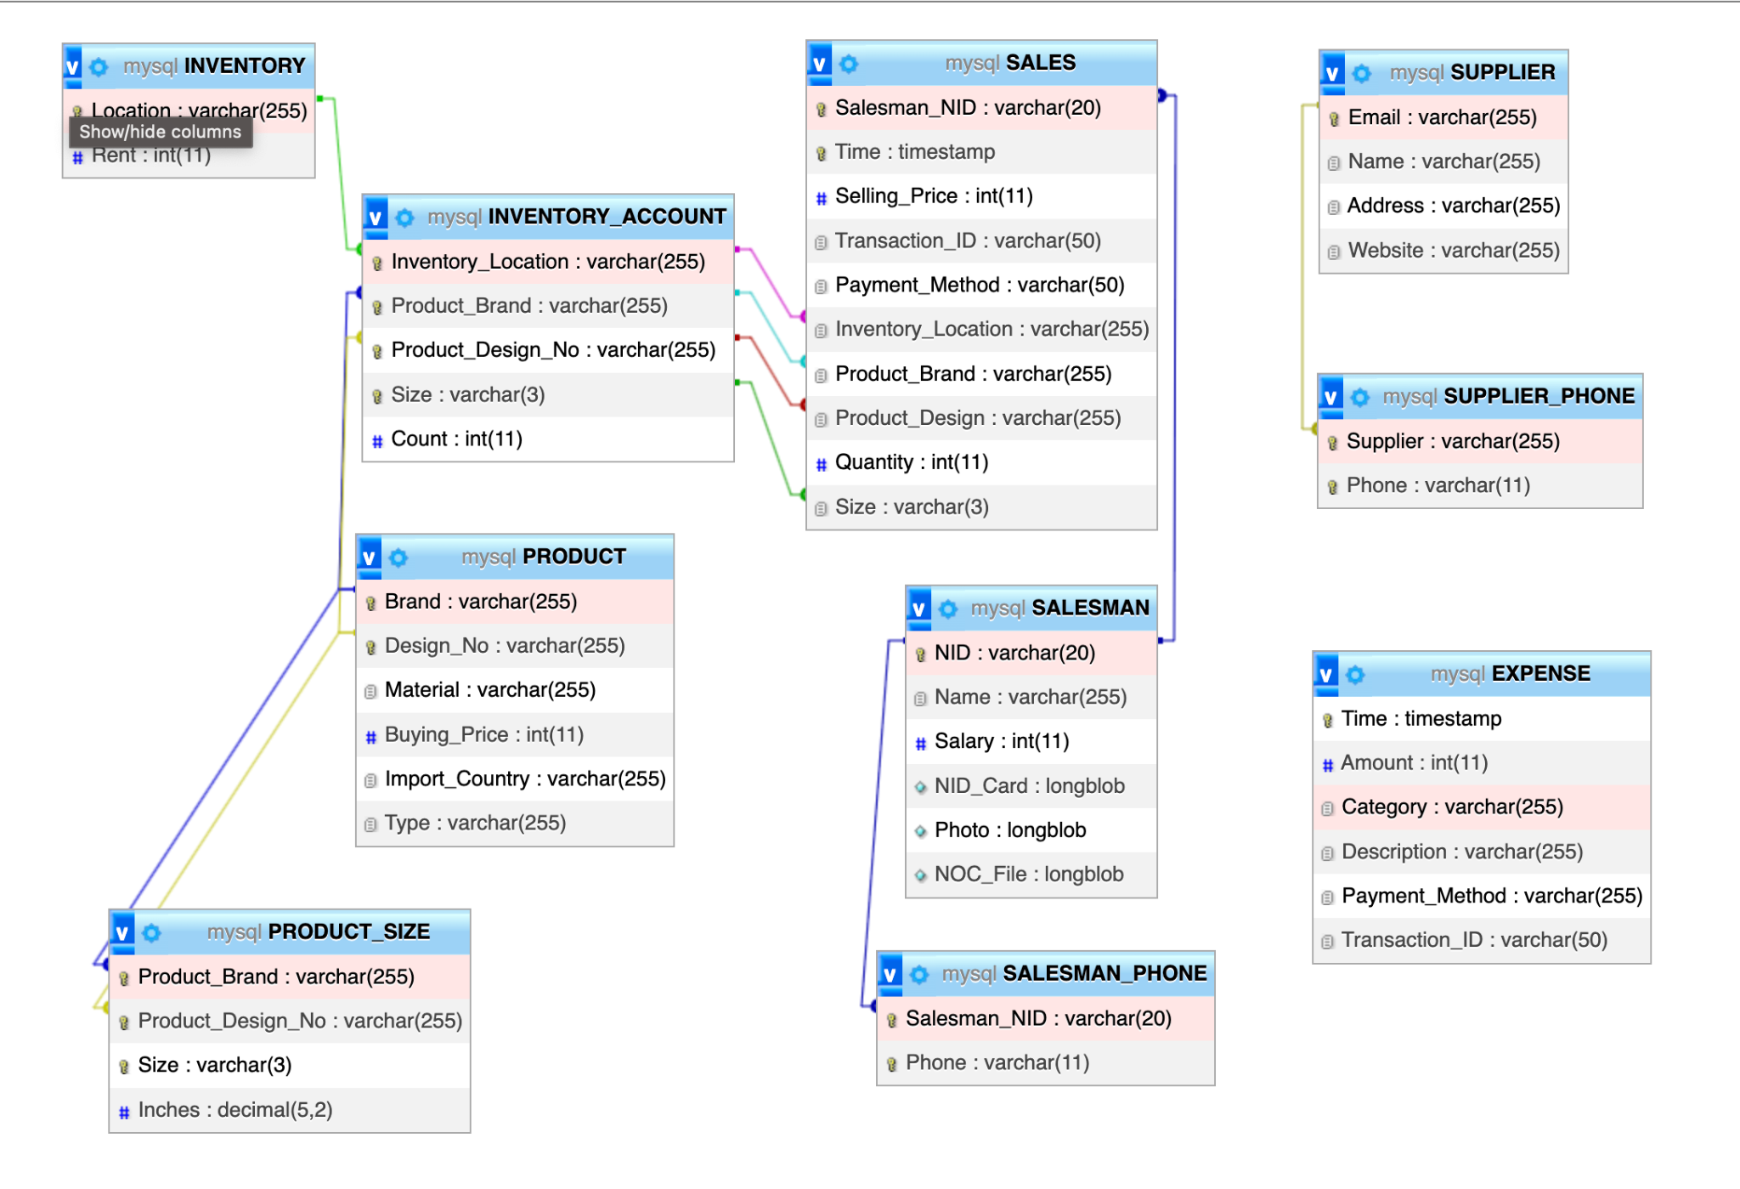

The Database Schema was Derived Directly from the ERD previously modelled.

Previously Designed ERD (Rejected):  
